CPU City Game Play Development

Overview of Fetch Decode Execute Cycle

Group Document to be annotated by Team members with ideas for artwork/locations/game mechanics etc

**Von Neumann Architecture** – example assembly language program instructions and data stored in RAM

1. LDA 3
2. SUB 4
3. HLT
4. 13
5. 8

**Locations**

CU: Control Unit

ALU: Arithmetic Logic Unit

RAM: Random Access Memory

**Registers**

PC: Program Counter (holds the address of next instruction in RAM)

MAR: Memory Address Register (holds current address in RAM)

MDR: Memory Data Register (Holds current data fetched from RAM or to be stored in RAM)

CIR: Current Instruction Register

ACC: Accumulator – holds values and results from the ALU

**Buses**

Control Bus

Address Bus

Data Bus

**Game Play**

The player will start at **the control unit** and travel via the control bus to the Program Counter.

After visiting the **PC** the player must travel via the address bus to the memory location 0 in **RAM** and **fetch** the first instruction (LDA 3: Load Data from Address 3 to the Accumulator).

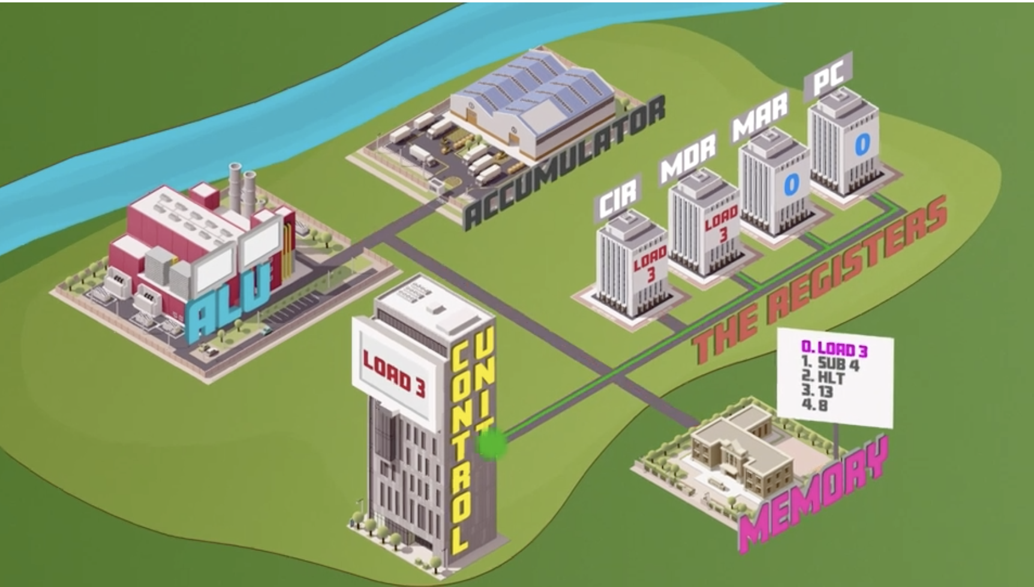 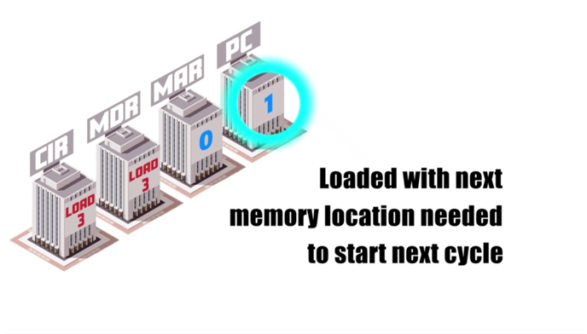

The player must then travel on the data bus to the **MDR**, to store the fetched instruction. The message must also be copied to the **CIR.** Then the instruction must be returned to the **CU** to be **decoded**.

The player then travels by control bus to increment the **PC**, then returns to the **CU** to receive the decoded **execute instruction** (in this example to fetch data from memory location 3 and load it into the accumulator).

The player travels on the control bus to update the **MAR** (to 3) before returning to **RAM** to fetch the **data** stored in memory location 3 (13).

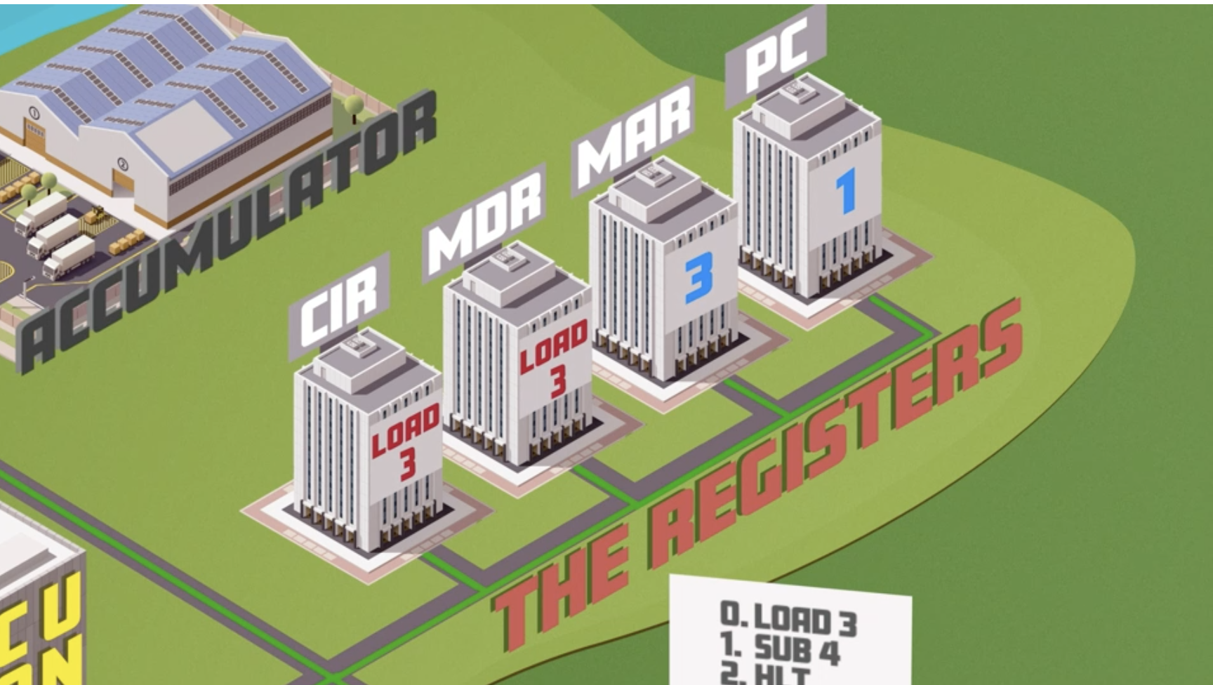 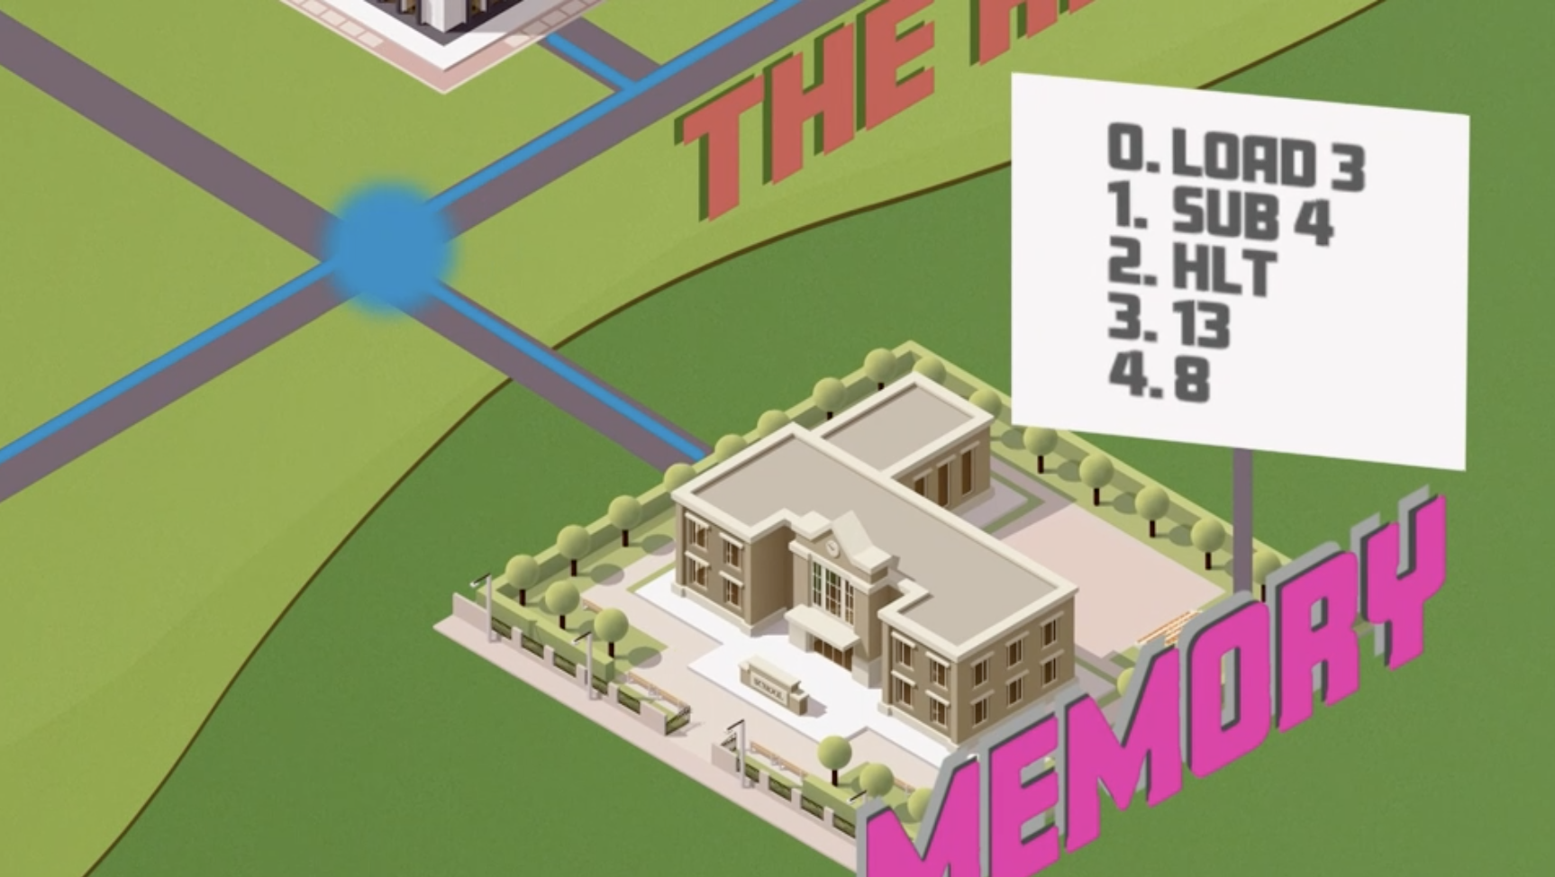

The player must then travel on the data bus to the **MDR** to store the current data value (13).

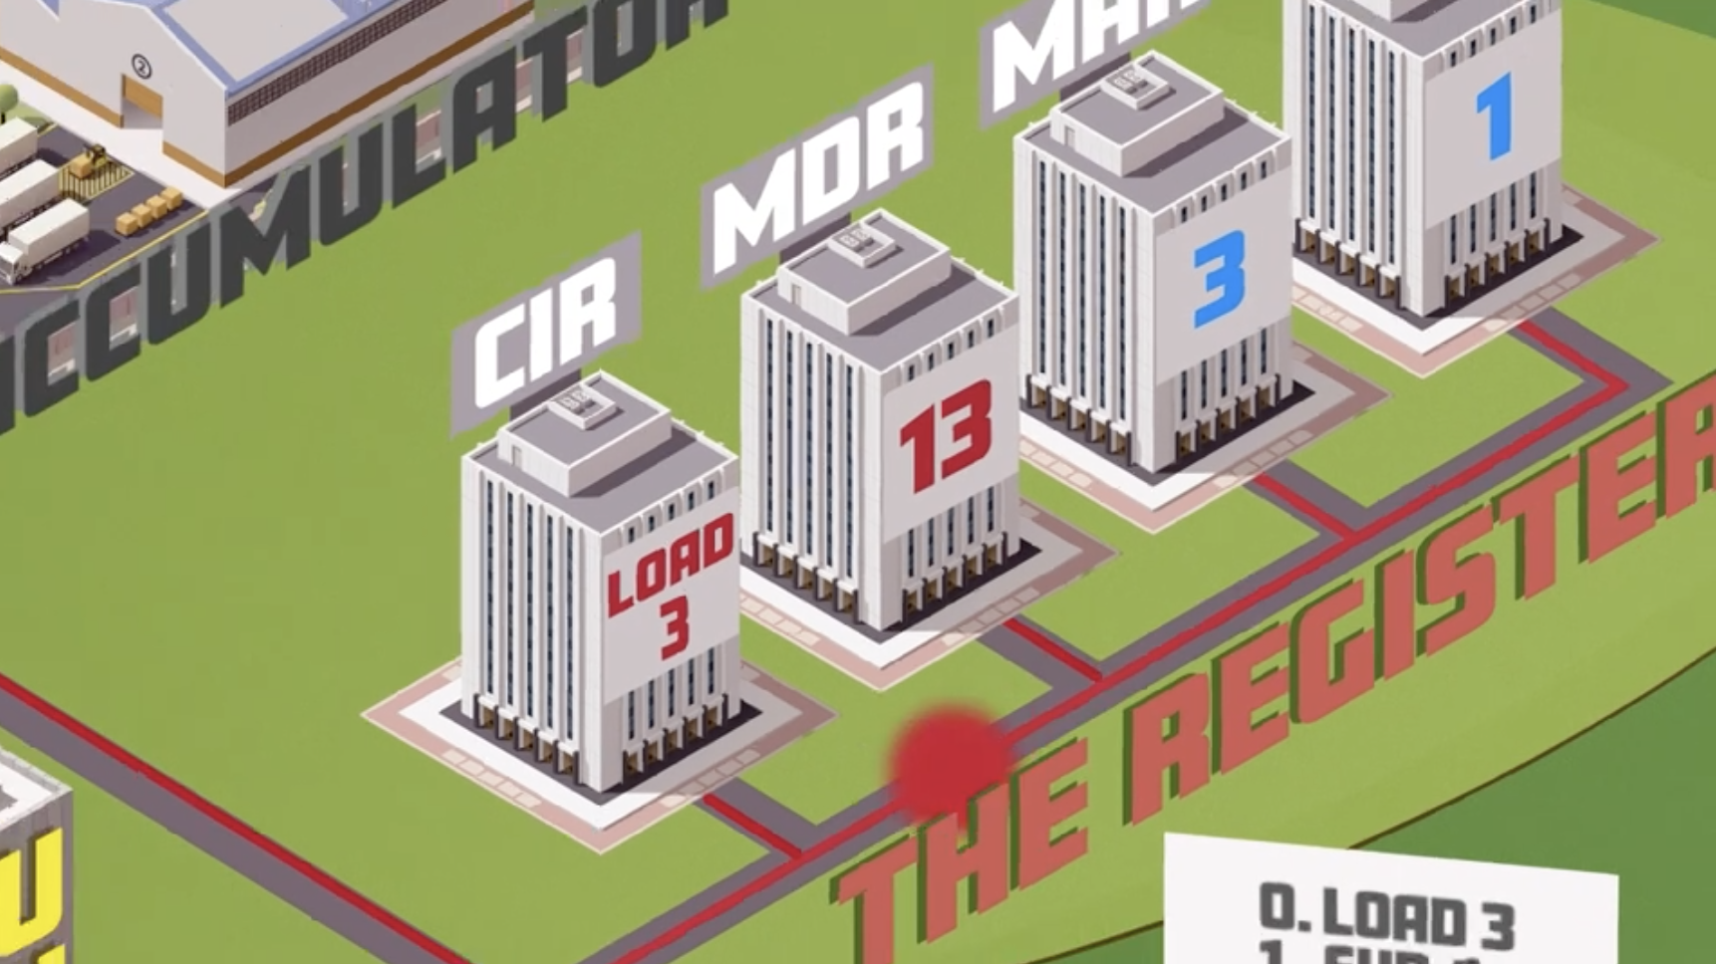 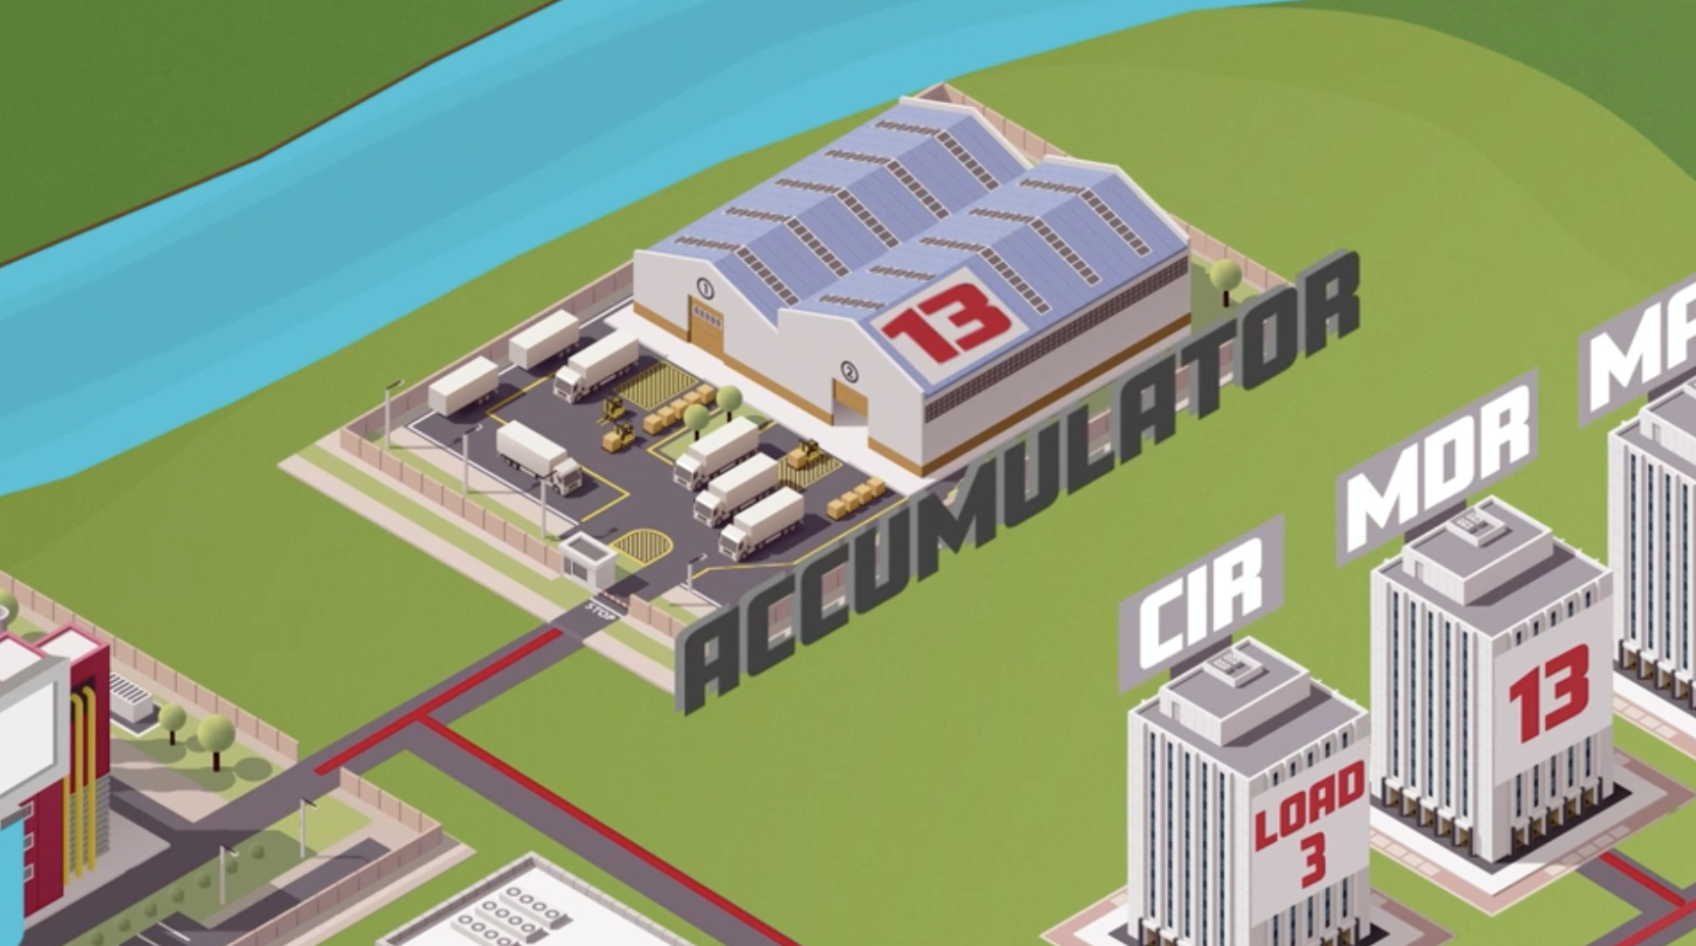

Then the player travels via the data bus to store the value in the **accumulator**.

The player has now **completed the first FDE cycle** and must return to the **CU** before travelling on the control bus to the **PC** to read the location in RAM of the next instruction (1 in this example).

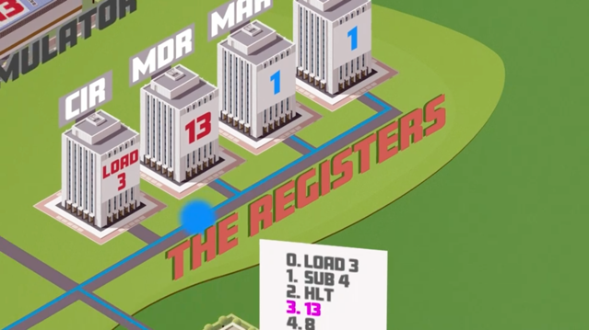 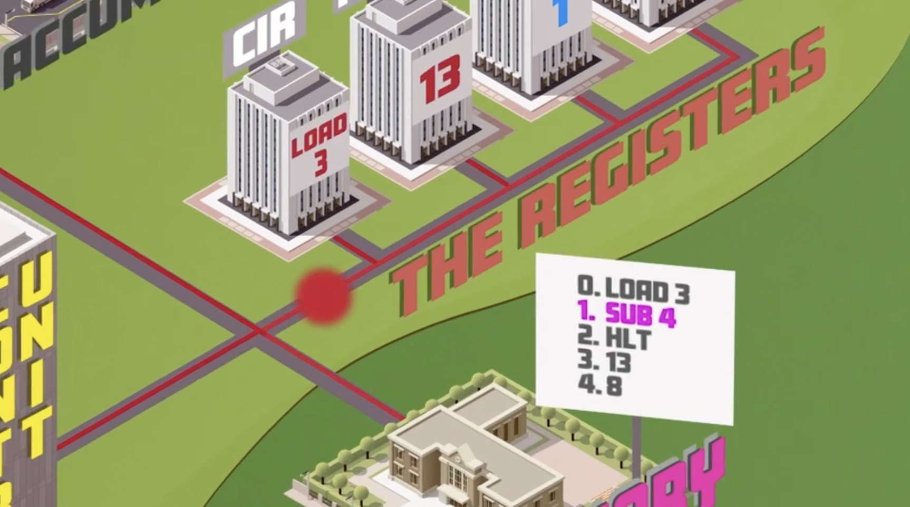

The address of the next instruction must be copied to the **MAR** before travelling on the address bus back to **RAM** and fetching the **instruction** stored in memory location 1 (SUB 4).

The player travels on the data bus back to the **MDR** to store the instruction. The instruction is also copied to the **CIR** before returning to the CU as the second fetch has now been completed.

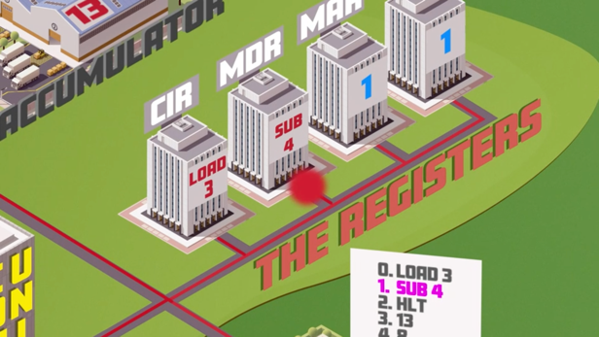 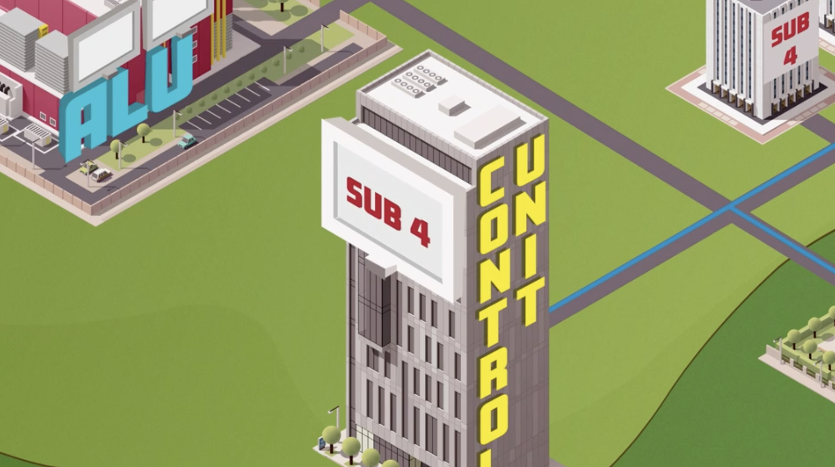

While the CU decodes the instruction the player takes the control bus to increment the **PC** before returning to the **CU** to receive the decoded instruction to execute (subtract the value stored in RAM memory location 4 from the value stored in the accumulator).

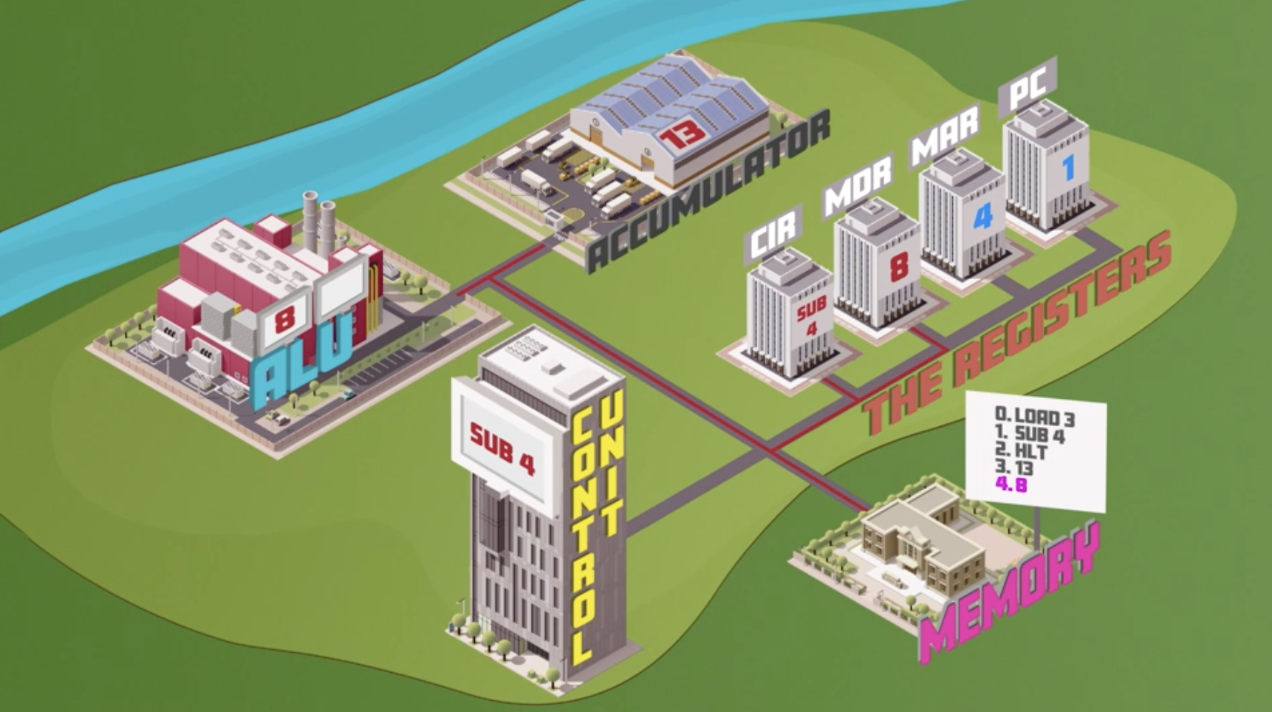 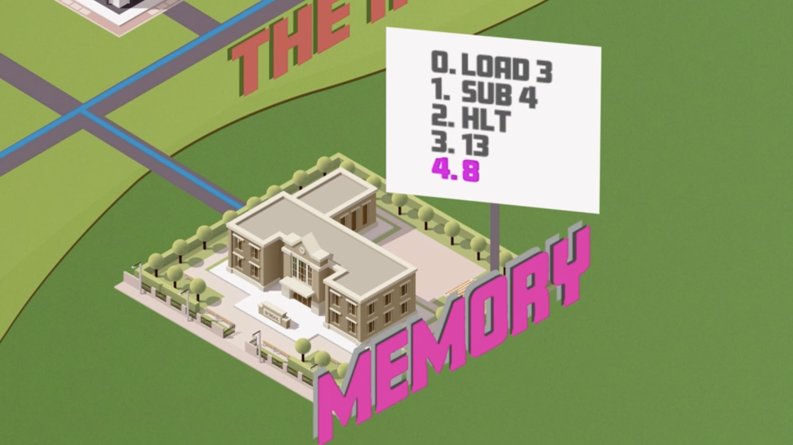

The player must first travel on the control bus from the CU to copy memory location 4 to the **MAR**, then travel by address bus back to **RAM** to fetch the value stored in memory location 4.

The player then travels via the data bus to update the **MDR** (with the value 8), before loading the value to the **ALU**. The value previously stored in the **ACC** (13) is also loaded into the ALU and the calculation is completed.

 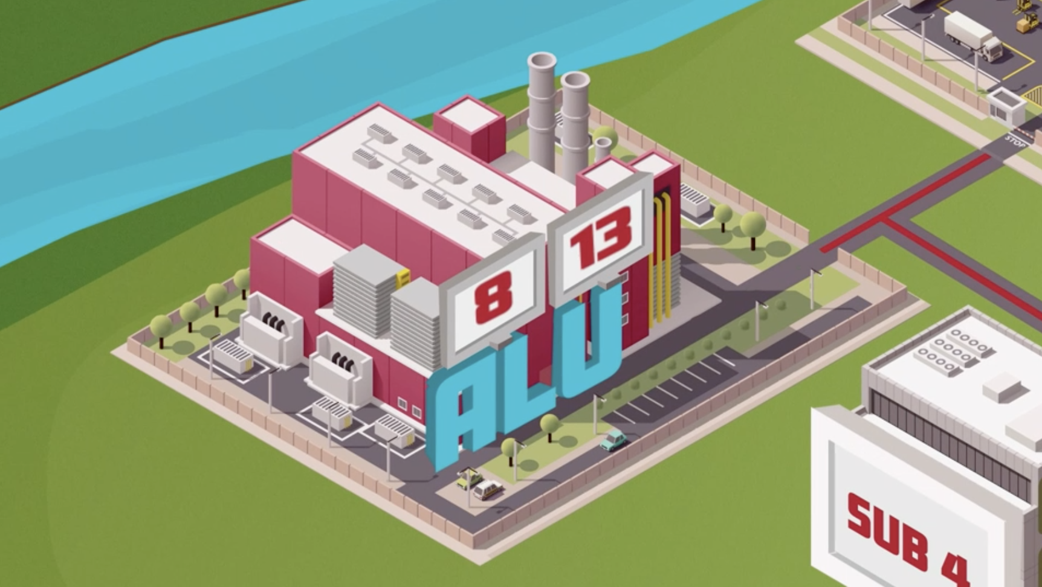

Finally, the resulting value (5) is transported via the data bus and stored in the **ACC**.

